12/02/2020 **CIA – 3** 1740256 ~ Jeevan Koshy

---------------------------------------------------------------------------------------------------------

1. Explain linguistic variables in fuzzy logic.

**Ans** A linguistic variable comes under the linguistic form along with propositions, if/then rules, algorithms and inference and plays a key role in applications. These variables collect elements into similar groups where we deal with less precisely and therefore enables us to handle more complex systems. Its values are composed of words or sentences in a natural or artificial language and also fuzzy variables. The variable’s mathematical representation of semantic concepts includes more than one term. It is made up of number of words that are associated with degrees of membership. Linguistic variables also represent crisp information in a form and precision appropriate for the problem. These variables are used everyday to express what is important and its context.

--------------------------------------------------------------------------------------------

1. Elaborate different membership functions in fuzzy logic.

**Ans** A membership function is a function that specifies the degree to which a given input belongs to a set. The different membership functions are used in the fuzzification and defuzzification steps of a fuzzy logic system which maps the non-fuzzy input values to fuzzy linguistic terms.

The different forms of membership functions are -

1. Triangular

Defined by a lower limit **a**, upper limit **b**, a value **m**, where a<m<b

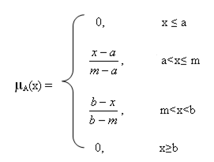

1. Trapezoidal

Defined by a lower limit **a**, an upper limit **d**, a lower support limit **b**, and an upper support limit **c**, where a < b < c < d.

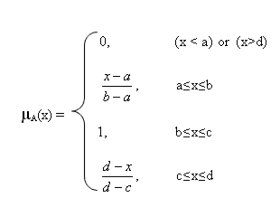

1. Piecewise linear

Is a function defined on the interval of real numbers.

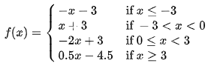

1. Gaussian

Defined by a central value **m**, with standard deviation k>0.

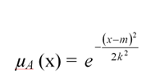

1. Singleton



